JOIN

A **JOIN** in SQL is used to combine rows from two or more tables based on a related column between them. Joins are a powerful feature of SQL that allow you to retrieve data from multiple tables as if they were a single table.

1). INNER JOIN

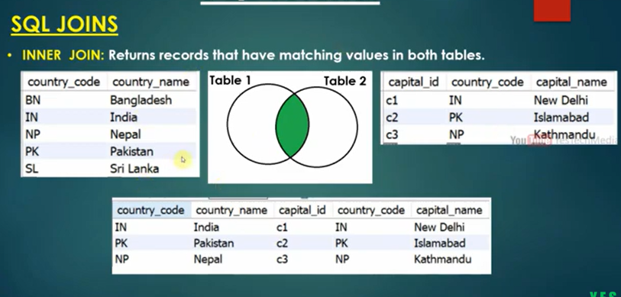

2). LEFT JOIN

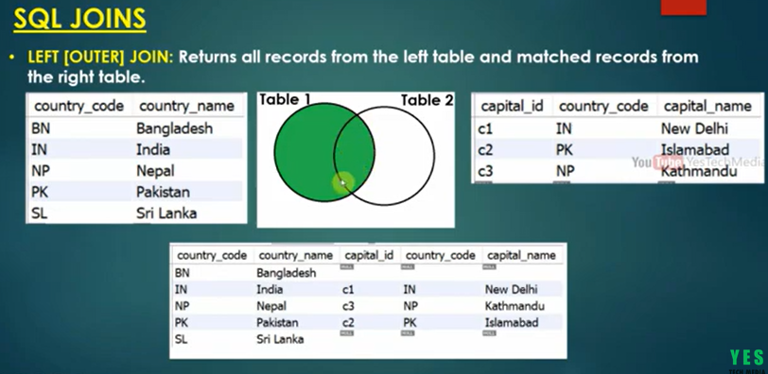

3). RIGHT JOIN

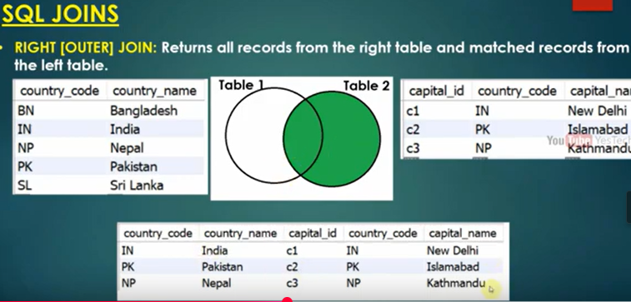

4) FULL JOIN

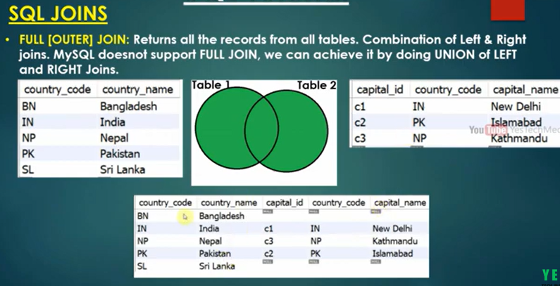

**CROSS JOIN**:

* Returns the Cartesian product of the two tables, i.e., every row in the first table is paired with every row in the second table.

**SELF JOIN**:

* A table is joined with itself